No. Bagde :
Full Name (same with KTP) : Arief Rizky
Address : Wisma Alamanda Jln. Cangkurawok Rt 01/ Rw 04 No.1 Desa Babakan Kecamatan Darmaga Kabupaten Bogor
Home Phone/ Mobile : - 085719723774
State : Indonesia
Place/Date of Birth(D.O.H) : Sigli / 25 July 1990
Blood type : - AB
Gender (L/P) : L
ID Number : 1107082507900001
Position :
Education : Major of Marine Science and Technology, Faculty of Fisheries and Marine Science and Technology, Bogor Agricultural University
Course Title : see page 2
Competencies : Two Star Scuba Diver POSSI-CMAS (License), Scientific of Coral Reef
Experiences : see page 2
Other Information :

Proposed by, Approved by, Approved by,

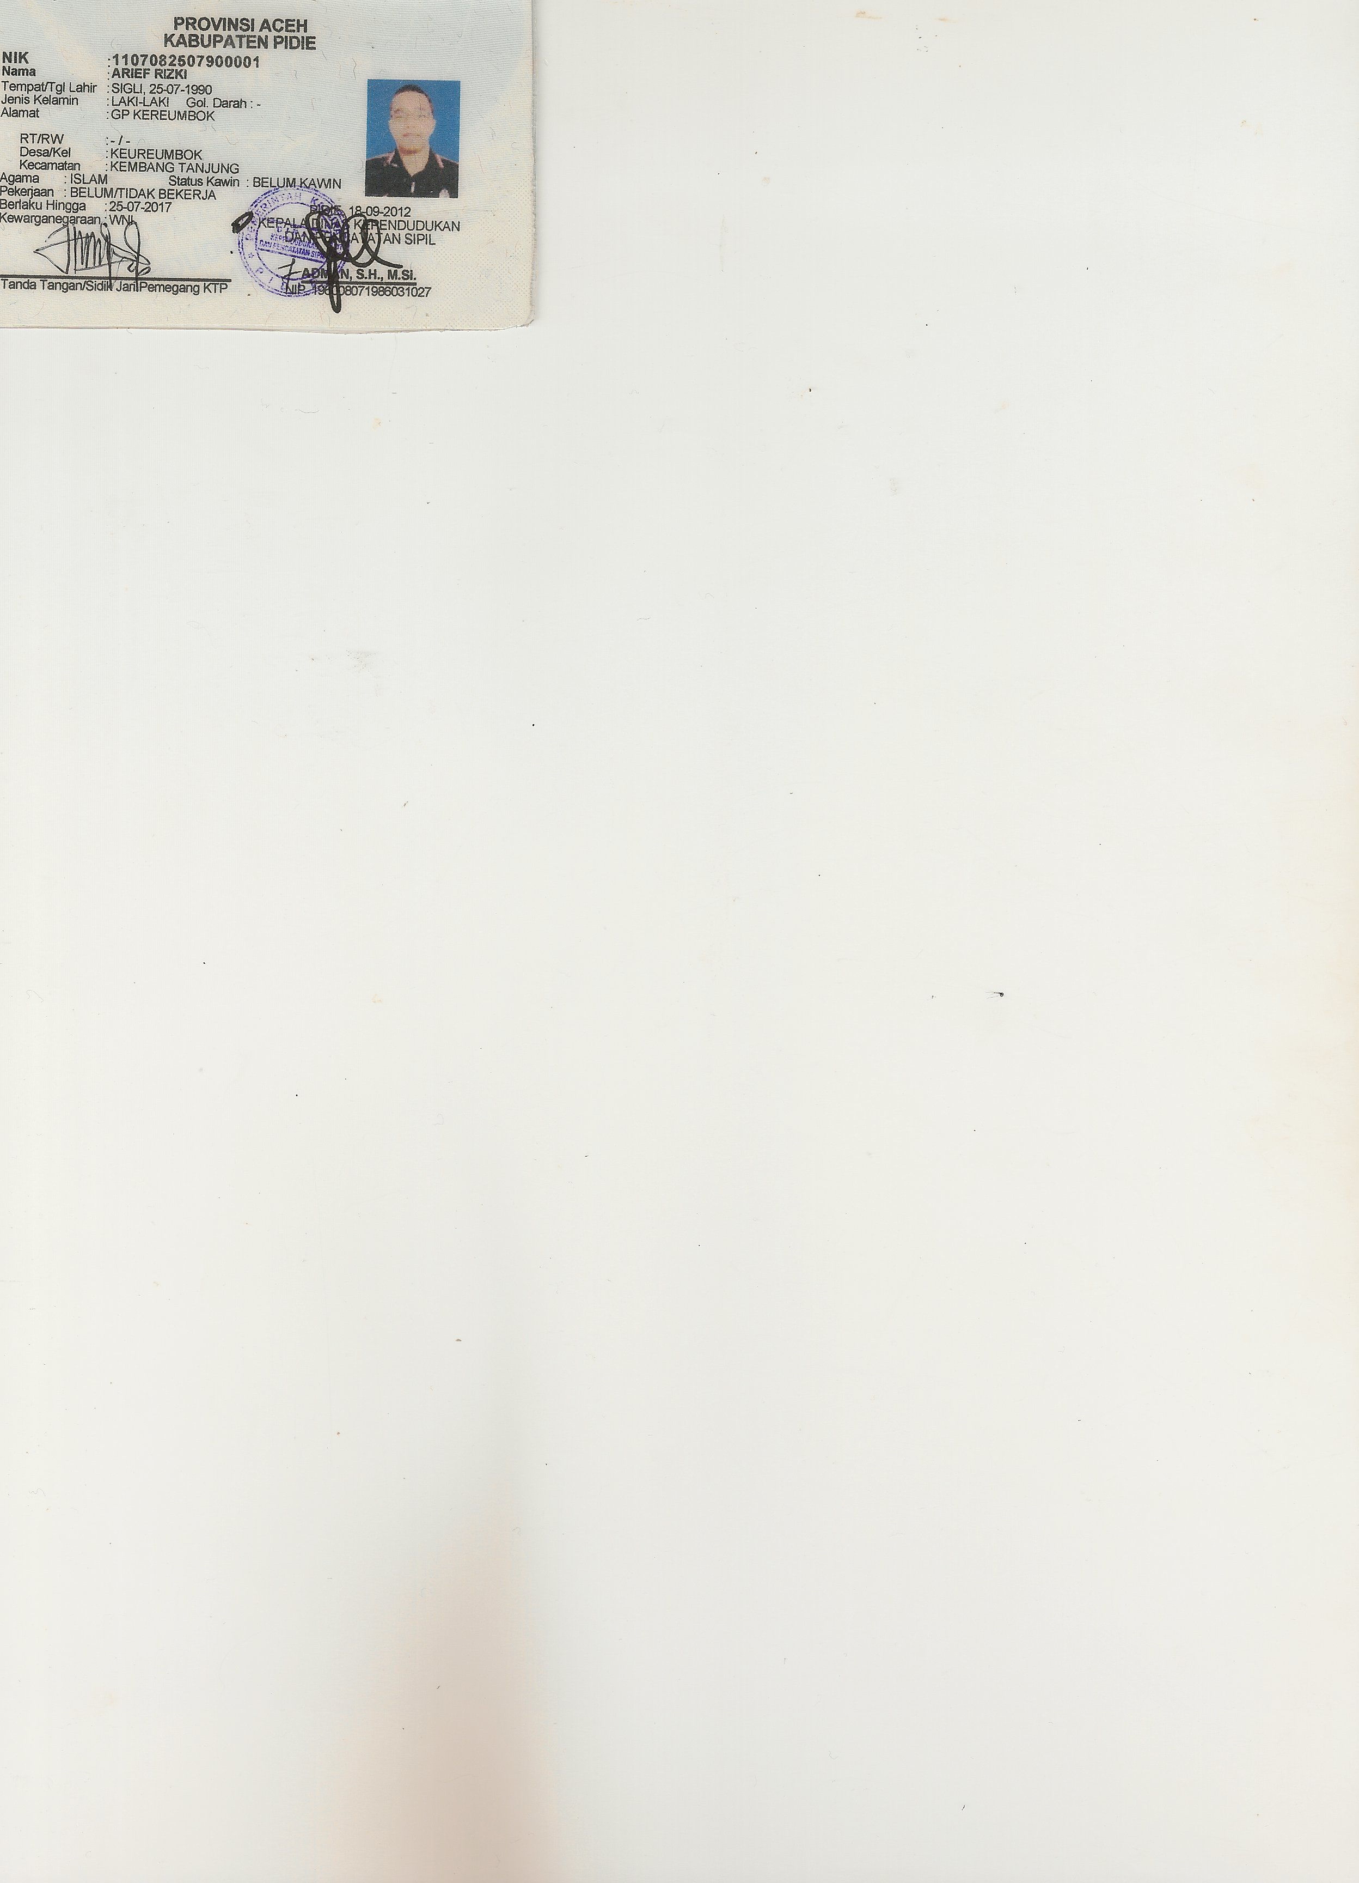

Contractor ( ) Contract Sponsor
Name : Arief Rizky
B/N :

TRAINING COURSE:
- Workshop and Launch Expedition Zooxantellae XI 2011 Fisheries Diving Club, Bogor Agricultural University at Kayoa Island, South Halmahera
- Workshop and Launch Expedition Zooxantellae X 2009 Fisheries Diving Club, Bogor Agricultural University at Biak Island, West Papua

FIELD WORK EXPERIENCE:
- Team Monitoring Coral Reef Ecosystem Wildlife Conservation Society 2012 at Karimun Jawa Island, Central Java
- Team Monitoring Coral Reef and System Information Geographic BAKOSURTANAL 2012 at Raja Ampat Island, West Papua
- Team Monitoring Coral Reef Expedition Zooxanthellae XI 2011 Fisheries Diving Club, Bogor Agricultural University at Kayoa Island, South Halmahera
- Team Monitoring Coral Reef Expedition Zooxantellae X 2009 Fisheries Diving Club, Bogor Agricultural University at Biak Island, West Papua

